AN EFFICIENT NOVEL APPROACH FOR PREDICTION OF START-UP COMPANY SUCCESS RATES THROUGH ML PARADIGMS
Abstract:
Start-up companies are crucial for economic growth and innovation, yet they face high failure rates due to various dynamic and uncertain factors. Predicting the success or failure of a start-up at an early stage can help stakeholders make informed investment and operational decisions. Traditional analytical methods often fail to account for complex, nonlinear relationships in entrepreneurial ecosystems. This study presents a novel and efficient machine learning-based approach to predict the success rate of start-ups using historical and real-time business data. By leveraging classification and regression algorithms, including ensemble methods and deep learning techniques, the model identifies key success factors such as funding stage, founder experience, market trends, and customer engagement metrics. The proposed system aims to increase predictive accuracy, provide actionable insights, and assist investors, founders, and incubators in strategic planning.

Existing System:
In the current ecosystem, start-up evaluations are typically carried out using manual assessment techniques, financial ratio analysis, SWOT (Strengths, Weaknesses, Opportunities, Threats) analysis, or traditional statistical models. These approaches rely heavily on human expertise and predefined criteria, which may not adequately capture the complexities and evolving nature of start-ups.
Additionally, some platforms utilize basic machine learning models with limited features and datasets. These models often employ logistic regression or decision trees trained on sparse and outdated data, leading to low generalizability and poor predictive performance when applied to real-world scenarios. Many systems lack the capability to dynamically learn from new data, adapt to market changes, or consider the multifaceted interactions between different business variables.

Existing System Disadvantages:
• Low Accuracy: Traditional and shallow ML models often fail to capture complex patterns in data, leading to inaccurate predictions.
• Limited Feature Scope: Most existing systems do not consider real-time data, such as customer behavior, social media sentiment, or founder networks.

Proposed System:
The proposed system introduces an advanced, data-driven machine learning framework that integrates multiple data sources to forecast start-up success with high accuracy and reliability. Using supervised learning techniques such as Random Forests, Gradient Boosting Machines (GBM), and Neural Networks, the model is trained on a rich dataset including funding rounds, founder profiles, industry sector, investor types, geographic location, market competition, and digital footprint metrics.
The system is designed to be dynamic and self-improving. It continuously learns from new data inputs and adapts its prediction patterns accordingly. Feature engineering and dimensionality reduction techniques are applied to identify the most influential variables. Moreover, the architecture supports explainable AI (XAI) techniques to offer transparency into why specific predictions are made, which is essential for stakeholders.
To enhance usability, the system is implemented with a user-friendly interface for investors and business analysts. It includes visual analytics dashboards, confidence scores, and actionable recommendations, making it not only a prediction engine but also a decision support system.

Proposed System of Advantages:
• Higher Prediction Accuracy: Utilizes complex ML algorithms capable of modeling nonlinear relationships and high-dimensional data.
• Real-Time Analytics: Integrates real-time data feeds for up-to-date predictions and market responsiveness.
• Automated Learning: Continuously improves its performance by learning from new outcomes and market trends.

System Architecture:

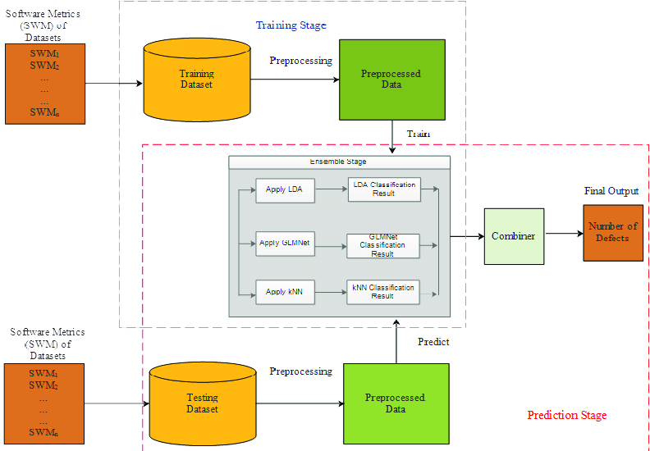

SYSTEM REQUIREMENTS:

HARDWARE REQUIREMENTS:

• System : Pentium IV 2.4 GHz.
• Hard Disk : 40 GB.
• Ram : 512 Mb.

SOFTWARE REQUIREMENTS:

• Operating system : - Windows.
• Coding Language : python.

